FULL ADDER

OBJECTIVE:
- To observe the working of full adder
THEORY:
Full adder: A full adder is a logical circuit that performs an addition operation on three binary digits. The full adder produces a ‘sum’ and ‘carry’ value, which are both binary digits. It can be combined with other full adders or work on its own.

EQUATION FOR FULL ADDER:

EQUIPMENT / REQUIREMENT:
- IC 7486
- 7408 IC.
- 7432 IC.
- Breadboard
- LED
- 0-5 VOLT DC Power Supply.

PROCEDURE:
Construct the combinational circuit as diagram given figure 7.1. After constructing both of these circuits, observe the output and complete the truth table.
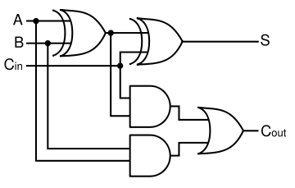
Figure 7.1 Full adder circuit

OBSERVATION TABLE:

A | B | Cī | Co | S
0 | 0 | 0
0 | 0 | 1
0 | 1 | 0
0 | 1 | 1
1 | 0 | 0
1 | 0 | 1
1 | 1 | 0
1 | 1 | 1
Table 7.1

QUESTIONS / RESULTS:

- A full adder can be constructed from ____half adders by connecting A and B to the input of ____ half adder
- Full adder performs the arithmetic addition of ______input bits.
- The ______ adder is one that does not take a carry-in from another adder.

CONCLUSION:

